LAB # 03
INTRODUCTION TO CONCURRENCY
OBJECTIVE:
Understanding and implementing the concept of concurrency through different mechanisms of multithreading.
LAB TASK:
- Implement the following program on eclipse IDE and answer the following questions:
- How many threads are running?
- How many tasks are running?
- If more tasks are added than what will be the impact on number of threads?
- Explain the flow of program:

class Main extends Thread{
public void run(){
System.out.println("task one");
}
public static void main(String args[]){
Main t1=new Main();
Main t2=new Main();
Main t3=new Main();
t1.start();
t2.start();
t3.start();
}
}

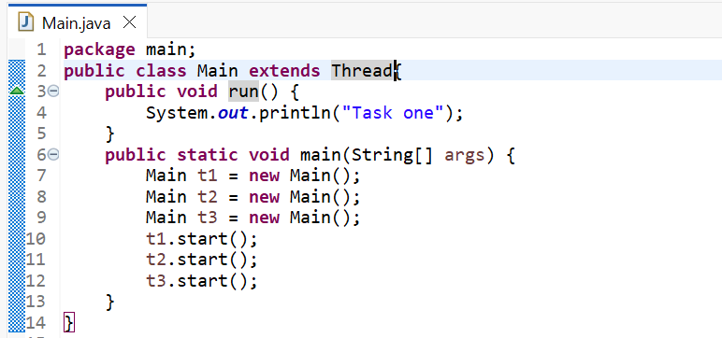
IMPLEMENTATION OF ABOVE CODE:
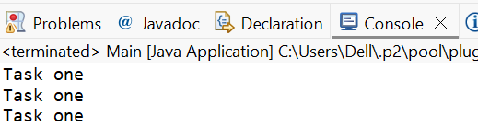
OUTPUT:
- HOW MANY THREADS ARE RUNNING?
There are total four (04) threads running in the above program. One is the main thread which runs the main( ) method. And the other three threads which are user threads i.e; t1, t2, t3 that each print the “Task one.”

- HOW MANY TASKS ARE RUNNING:
Each thread perform one task of printing “Task one”. Since there are three threads which we started, so we have three tasks in the above program.

- IF MORE TASKS ARE ADDED THAN WHAT WILL BE THE IMPACT ON NUMBER OF THREADS?
If more tasks are added in the above program than more threads will be created. And each thread handle it’s own task.

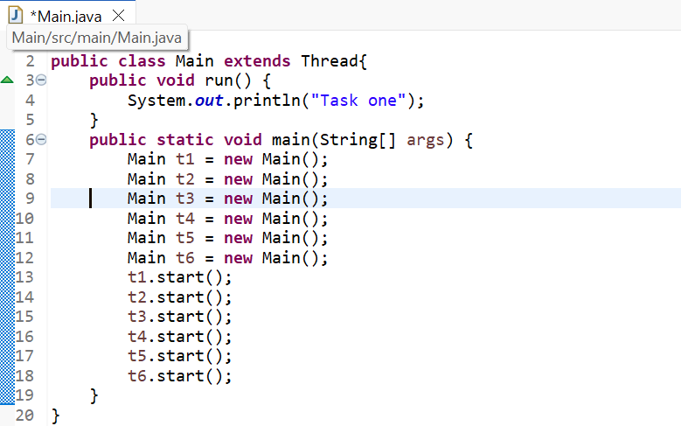
CODE WITH MORE TASKS:
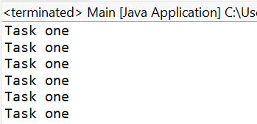
OUTPUT:

- EXPLAIN THE FLOW OF PROGRAM:

- The program starts with main thread.
- It creates three threads i.e; t1, t2, t3.
- Each thread starts and runs the run( ) method.
- Every thread prints “Task one” in the output.

- With the help of threading print two tables concurrently, print one table number of student roll number e.g. 2019-SE-092 and second number should be date of birth e.g. 05-April.

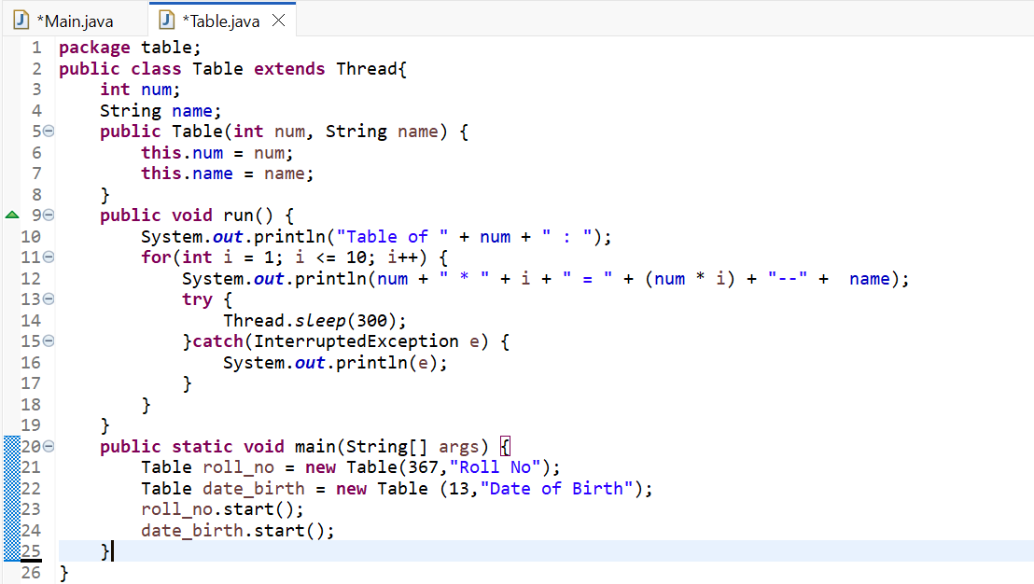
CODE:

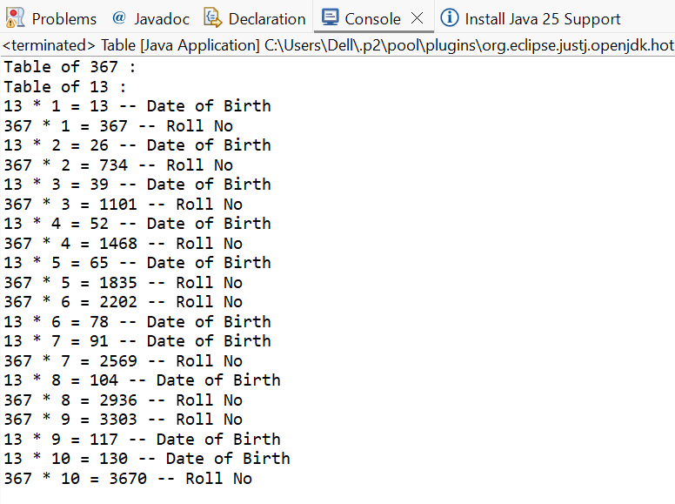
OUTPUT:

